Name: Shruti Popat Patil

Roll No.: 243549

**Set Assignments:**

1. Add a list of elements to a given set

Given:

sampleSet = {"Yellow", "Orange", "Black"}

sampleList = ["Blue", "Green", "Red","Yellow","orange"]

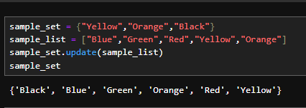

2. display common elements from the given set

set1 = {10, 20, 30, 40, 50}

set2 = {30, 40, 50, 60, 70}

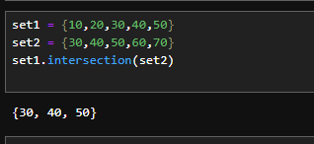

3. Generate a new set with all items from both sets by removing numbers which are in both sets.

set1 = {10, 20, 30, 40, 50,25}

set2 = {30, 40, 50, 60, 70,100}

o/p : order is not important

{70, 10, 20, 60,25,100}

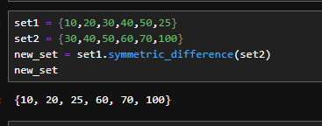

4. set of all elements in either A or B, but not both

set1 = {10, 20, 30, 40, 50}

set2 = {30, 40, 50, 60, 70}

Expected output:

{20, 70, 10, 60}

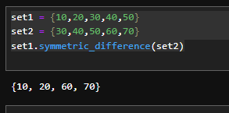

5. Update set1 by adding items from set2, except common items

set1 = {10, 20, 30, 40, 50}

set2 = {30, 40, 50, 60, 70}

Expected output:

{70, 10, 20, 60}

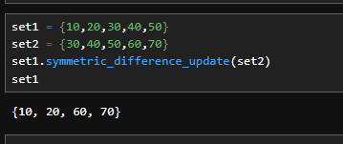

6. Take a sentence as input from user. Every word is seperated by space. Print all unique words from the sentence.

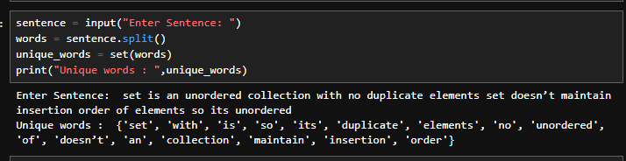

**Tuple Assignments**

1. Reverse the following tuple

aTuple = (10, 20, 30, 40, 50,60)

Expected output:

(60,50, 40, 30, 20, 10)

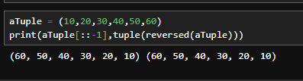

2. display value 20 from the following tuple

aTuple = ("Orange", [10, 20, 30], (5, 15, 25))

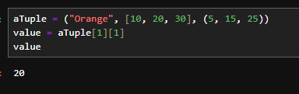

3. Unpack the following tuple into 4 variables

aTuple = (10, 20, 30, 40)

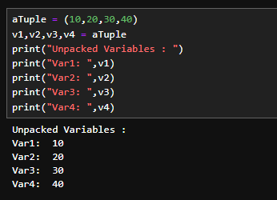

4. Swap the following two tuples

tuple1 = (11, 22)

tuple2 = (99, 88)

Expected output:

tuple1 = (99, 88)

tuple2 = (11, 22)

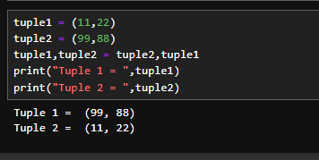

5. Copy element 44 and 55 from the following tuple into a new tuple

tuple1 = (11, 22, 33, 44, 55, 66)

Expected output:

tuple2: (44, 55)

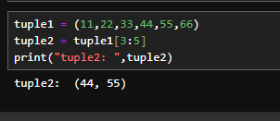

6. Modify the first item (22) of a list inside a following tuple to 200

tuple1 = (11, [22, 33], 44, 55)

Expected output:

tuple1: (11, [200, 33], 44, 55)

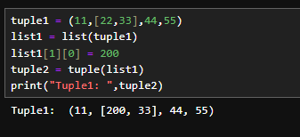

7. Take two integer values in a & b. Swap their values using tuple, using temparary variable and without tuple and without temparary variable.

Ex. a=10 b=23

After swapping a=23 b=10

